

Worksheet 4: BODY PART MEASURING IN EUROPE

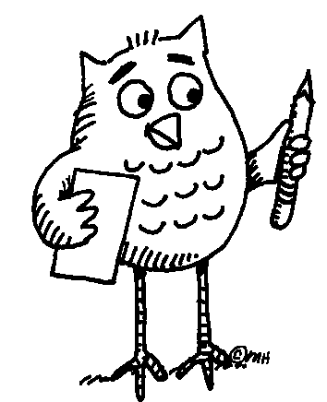 Task 1: Read the text using the dictionary to clarify the meaning of unknown words.
“ … 4 fingers make a palm, and 4 palms make a foot; 6 palms make 1 cubit, 4 cubits make a man's height, and 4 cubits make one pace ... “

From: The Notebooks of Leonardo da Vinci (original edition 1883

Task 2: Measure yourself or each other to verify the above statement.

Task 3: Compare the names of measures in English, Czech, French and Italian. Complete the table below.
4 doigts font une paume, et 4 paumes font un pied; 6 paumes font une coudée, 4 coudées font la taille d’un homme, et 4 coudées font un pas ...
4 diti fa un palmo, e 4 palmi fa un pie; 6 palmi fa un cubito, 4 cubiti fa un homo, e 4 cubiti fa un passo ...
4 prsty představují dlaň a 4 dlaně jsou jedna stopa; 6 dlaní představuje 1 loket, 4 lokte představují výšku člověka a 4 lokte představují i krok …
ENGLISH CZECH FRENCH ITALIAN YOUR LANGUAGE
4 fingers
a palm
a foot
1 cubit

... Follow up activity for the whole class:
Can you give examples of body part counting or measuring in your culture?

